ULTRASOUND IMAGING
What is ultrasound imaging?
- Ultrasound imaging uses high-frequency sound waves to create real-time images of structures inside the body.
- A handheld device called a transducer sends sound waves into the body and detects the echoes that bounce back from tissues.
- Different tissues reflect sound differently, allowing muscles, tendons, fat, and bone to be distinguished in the image.
- B-mode (brightness mode) ultrasound is the most common form of ultrasound imaging. The brightness of each pixel represents the strength of the reflected sound wave.
- B-mode ultrasound produces a two-dimensional cross-sectional image of the tissues beneath the skin.
- Unlike X-rays, ultrasound does not use ionising radiation, making it a safe and widely used imaging technique.
- Because images are generated in real time, ultrasound allows us to observe muscles as they move and contract.
What can you see?
- Individual muscles can be identified by their characteristic shape and internal structure.
- The thin layers of connective tissue within and between muscles appear as bright lines in the image.
- Tendons and bones can also be visualised, although bone reflects most of the ultrasound signal and appears as a bright boundary.
- Changes in muscle shape can be observed as muscles contract and relax.
- Ultrasound can reveal how muscles move beneath the skin, even when little or no movement is visible externally.
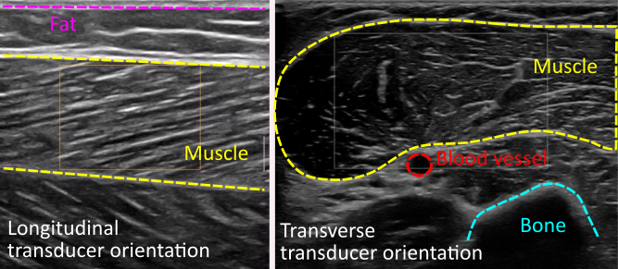
Why is ultrasound useful?
- Ultrasound is widely used in sports science, biomechanics, rehabilitation, and clinical medicine.
- Researchers use ultrasound to investigate muscle architecture, tendon behaviour, and movement mechanics.
- Clinicians use ultrasound to assess muscle and tendon injuries and monitor recovery.
- Ultrasound helps us better understand how muscles produce movement and adapt to training, ageing, and disease.

